DEFECT REPORT DOCUMENT

**BUG SUMMARY**

|  |  |
| --- | --- |
| **Type of bugs** | **No. of bugs** |
| Webpage loading bugs | 1 |
| Registration page bugs | 2 |
| User page bugs | 1 |
| Ticket Booking bugs | 4, blocker |
| Ticket Cancellation bugs | blocker |
| Train timing bugs | 1 |

**Bug ID: B-0001**

**Title:** Browser Compatibility Issue.

**Description:** The Pakistan Railways website has problems working with some web browsers. It does not open at all on Microsoft Edge and sometimes does not open on Google Chrome. This makes it hard for people to use the website reliably.

**Steps to Reproduce:**

1. Open the Chrome or Edge browser.
2. Navigate to the <https://www.pakrail.gov.pk/>

**Expected Result:** The user should be redirected to the Pakistan railway page. **Actual Result:** The user is not redirected to the correct Pakistan railway page. **Severity**: High

**Priority:** High

**Reported by:** Haseeb Akram

**Assigned to:** Haseeb Akram

**Date Reported:** 25/7/2024

**Testing Environment:**

Browser: Google Chrome, Firefox, Edge Operating System: Windows, Android Device: Desktop, Mobile,

Network: Wi-Fi, 4G

# Attachments:

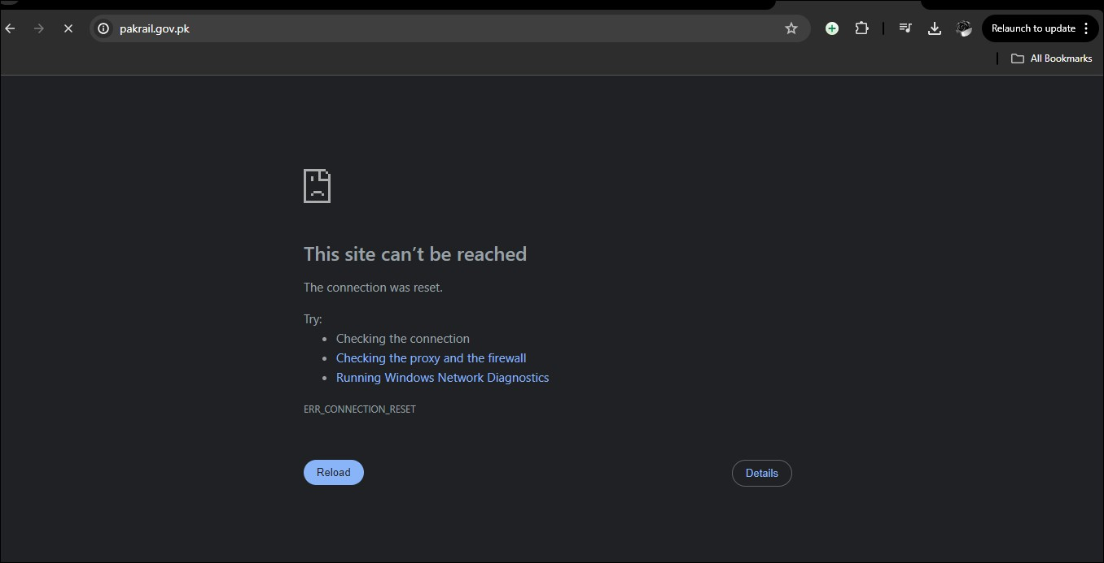

—

**Bug ID: B-0002**

**Title:** Specific date issue

**Description:** The seat date field on the booking page of the Pakistan Railways sign-up system is not editable, preventing users from selecting or modifying their travel date.

**Steps to Reproduce:**

1. Navigate to the homepage.
2. Click on the train timing option.
3. click on the date option.

**Expected Result:** The seat date should be editable.

**Actual Result:** The seat date cannot be editable.

**Severity**: Low

**Priority:** High

**Reported by:** Haseeb Akram

**Assigned to:** Haseeb Akram **Date Reported:** 25/7/2024 **Testing Environment:** Browser: Firefox

Operating System: Windows, Android Device: Desktop, Mobile,

Network: Wi-Fi, 4G

# Attachments:

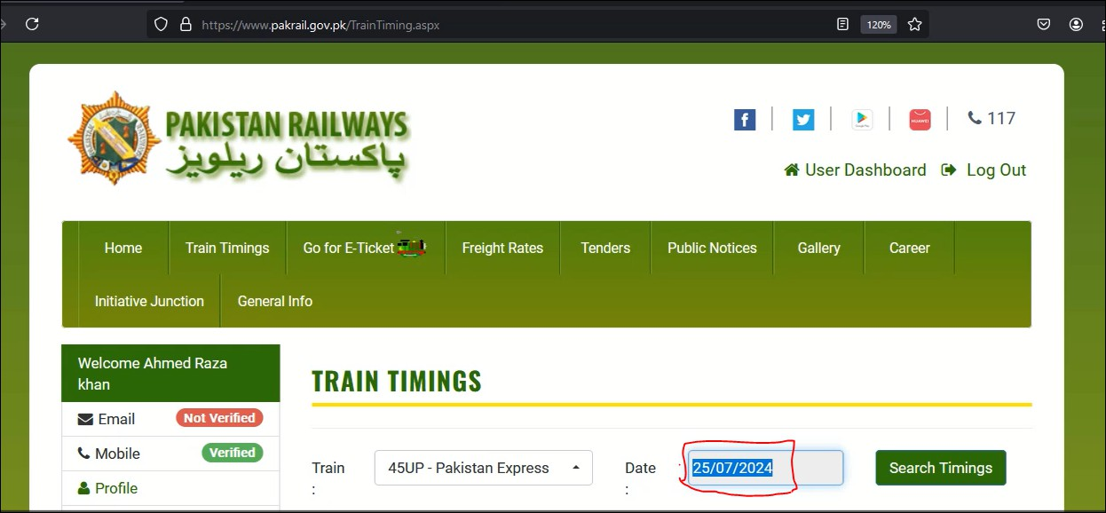

—

**Bug ID: B-0003**

**Title:** Seats Availability

**Description:** select the departure date first and then choose the "from" station and the "to" station, the details don't show up.

**Steps to Reproduce:**

1. Navigate to the E-ticket.
2. Click on the train Departure date.
3. select From Station to Station.4 Click on Search Seat

**Expected Result:** The departure date first and then chooses the "from" station and the "to" station, the details should be shown.

**Actual Result:** The departure date first and then chooses the "from" station and the "to" station, the details cannot be shown.

**Severity**: Low

**Priority:** High

**Reported by:** Haseeb Akram

**Assigned to:** Haseeb Akram

**Date Reported:** 25/7/2024

**Testing Environment:**

Browser: Firefox

Operating System: Windows, Android Device: Desktop, Mobile,

Network: Wi-Fi, 4G

# Attachments:

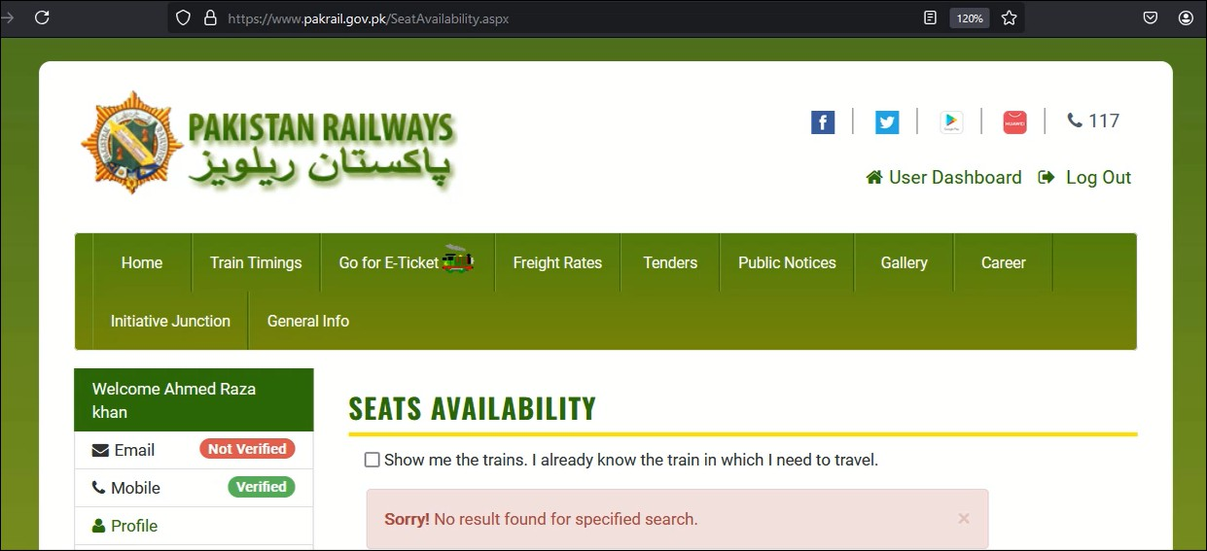

**—-----------------------------------------------------------------------------------------**

**Bug ID: B-0004**

**Title:** Train Timing

**Description:** When we select a train of our choice, the train timings only show for the same day.

**Steps to Reproduce:**

1. Navigate to the E-ticket.
2. Click on the train Departure date.
3. select From Station to Station.
4. Click on Search Seat.

**Expected Result**: When we click on the train Departure date it selects time that is editable.

**Actual Result:** When we click on the train Departure date it selects time that is current.

**Severity**: Low

**Priority:** High.

**Reported by:** Haseeb Akram **Assigned to:** Haseeb Akram

**Date Reported:** 25/7/2024 **Testing Environment:**

Browser: Firefox

Operating System: Windows, Android Device: Desktop, Mobile,

Network: Wi-Fi, 4G

# Attachments:



—

**Bug ID: B-0005**

**Title:** Email Verification

**Description:** When we click the email verification button, it shows: "Sorry! We couldn't send you an email. Please try again later."

**Steps to Reproduce:**

1. Navigate to the Home page
2. Go to the Personal info Field.
3. Click on the email.

4Click on the send verification email button.

**Expected Result:** When we click on the button of verify email it should send an email verification link to the email.

**Actual Result:** When we click on the button of verify email it is not sending an email verification link to the email.

**Severity**: Low

**Priority:** High.

**Reported by:** Haseeb Akram

**Assigned to:** Haseeb Akram **Date Reported:** 25/7/2024 **Testing Environment:** Browser: Firefox

Operating System: Windows, Android Device: Desktop, Mobile,

Network: Wi-Fi, 4G

# Attachments:

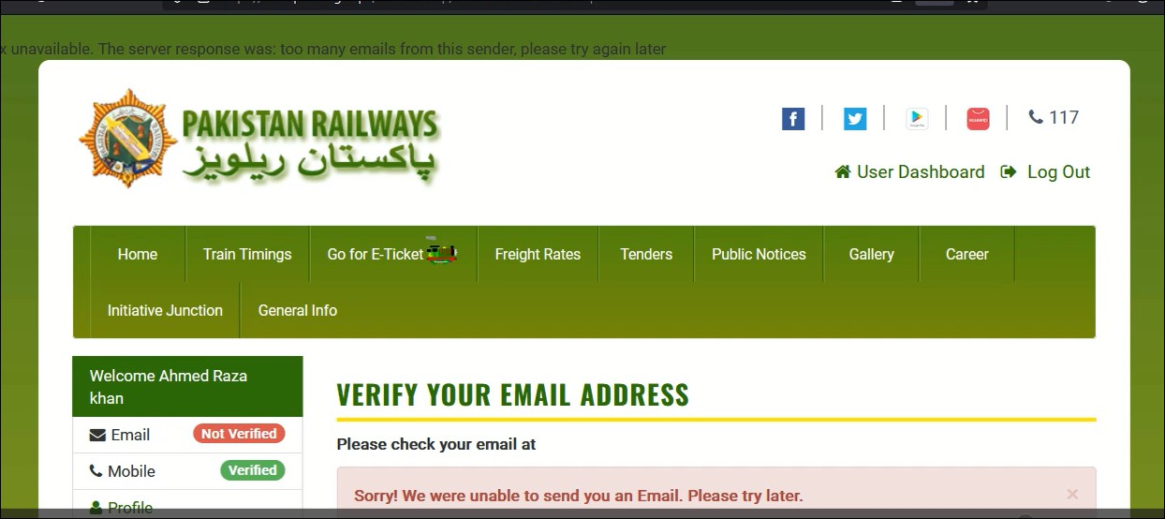

—

**Bug ID: B-0006**

**Title:** Exit Button not working.

**Description:** When we click on the exit button, it doesn't work.

**Steps to Reproduce:**

1. Navigate to the E-Ticket.
2. select the time and train.
3. Click the select seats option.
4. click the exit button in the bottom to exit the page.

**Expected Result:** When we click on the exit button it should click and functionable.

**Actual Result:** When we click on the exit button it cannot be click and functionable.

**Severity**: Low

**Priority:** Low

**Reported by:** Haseeb Akram

**Assigned to:** Haseeb Akram

**Date Reported:** 25/7/2024 **Testing Environment:** Browser: Firefox

Operating System: Windows, Android Device: Desktop, Mobile,

Network: Wi-Fi, 4G

# Attachments:

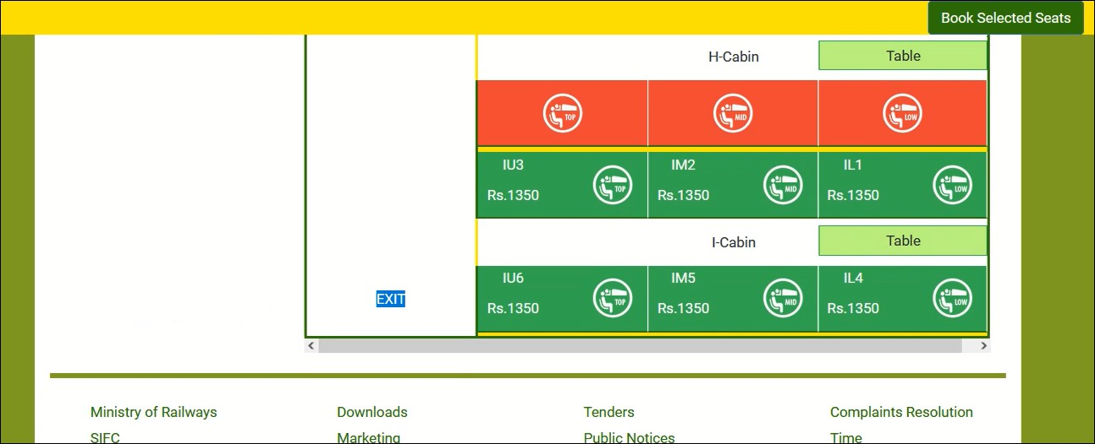

—

**Bug ID: B-0007**

**Title:** Ticket Booking.

**Description:** When we click the ticket booking option, it is not booking.

**Steps to Reproduce:**

1. Navigate to the Home page.
2. Go to the Book your train ticket section.
3. Click on your Source to Destination.
4. Select your Desired date.
5. Click on the booking button.

**Expected Result:** When we click the ticket booking option, it should be booked.

**Actual Result:** When we click the ticket booking option, it cannot not book.

**Severity**: Low

**Priority:** High.

**Reported by:** Haseeb Akram

**Assigned to:** Haseeb Akram

**Date Reported:** 25/7/2024

**Testing Environment:**

Browser: Firefox

Operating System: Windows, Android Device: Desktop, Mobile,

Network: Wi-Fi, 4G

# Attachments:

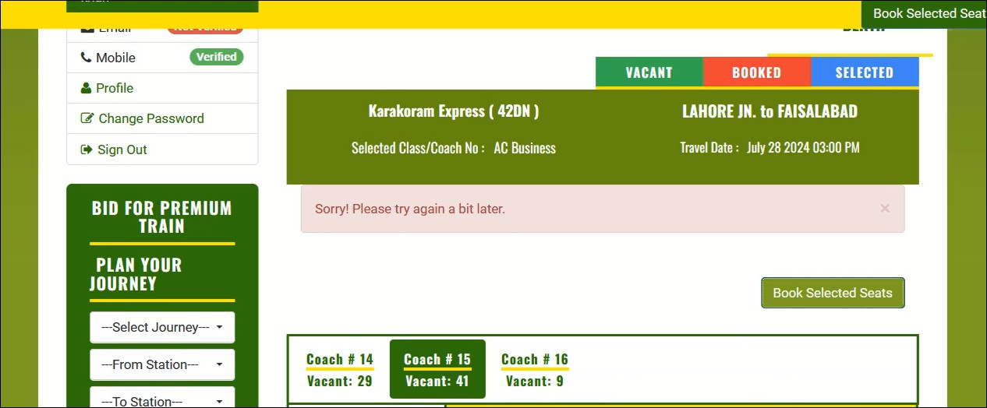

—

**Bug ID: B-0008**

**Title:** Not showing invalid email.

**Description:** When we enter invalid email in the registration page. It doesn’t show any error message that the email is not valid.

**Steps to Reproduce:**

1-Go to the registration page.

2.Enter the invalid email in the given field.

**Expected Result:** When we add an invalid email in the registration page it should show an error message of invalid email.

**Actual Result:** When we add an invalid email in the registration page it doesn’t show any error message of invalid email.

**Severity**: Low

**Priority:** Low

**Reported by:** Haseeb Akram **Assigned to:** Haseeb Akram

**Date Reported:** 25/7/2024 **Testing Environment:**

Browser: Firefox

Operating System: Windows, Android Device: Desktop, Mobile,

Network: Wi-Fi, 4G

# Attachments:

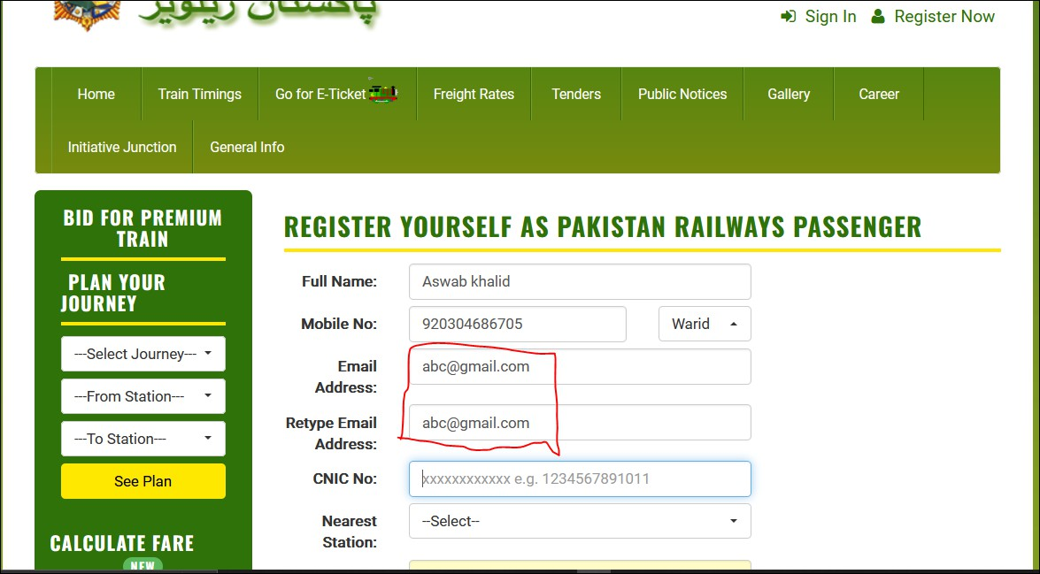

—

**Bug ID: B-0009**

**Title:** Not showing submit button

**Description:** When we put login details, it sometimes doesn’t show the submit button.

**Steps to Reproduce:**

1-Go to the registration page.

2.Enter the invalid email in the given field.

**Expected Result:** When we add an invalid email in the registration page it should show an error message of invalid email.

**Actual Result:** When we add an invalid email in the registration page it doesn’t show any error message of invalid email.

**Severity**: Low

**Priority:** High

**Reported by:** Haseeb Akram **Assigned to:** Haseeb Akram

**Date Reported:** 26/7/2024 **Testing Environment:**

Browser: Firefox

Operating System: Windows, Android Device: Desktop, Mobile,

Network: Wi-Fi, 4G

**Attachments:**

